3.2 I can identify any quality problems with websites and how to respond to them

I have gone to three websites: [www.thesun.co.uk](http://www.thesun.co.uk) [www.mashable.com](http://www.mashable.com) and [www.argos.co.uk](http://www.argos.co.uk) and I will be evaluating them on their speed of loading and what I think they should do to speed up their page.

**The Sun**



[The above photo shows that The Sun website and the page hasn’t fully loaded yet]

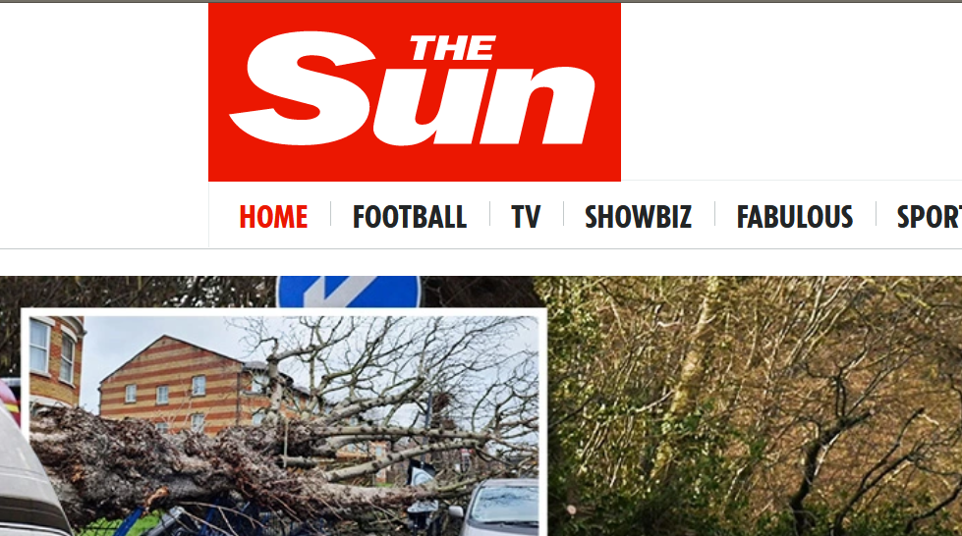

[The above photo shows that The Sun website fully loaded]

I think the website didn’t load very quickly because of the big photo on the front page that takes time to fully load. I think if they used a lower resolution photo for their page and then higher resolution photo for when the user clicks on the photo that it would load faster. This site does have accessibility options such as ALT on their photos though.

**Mashable**

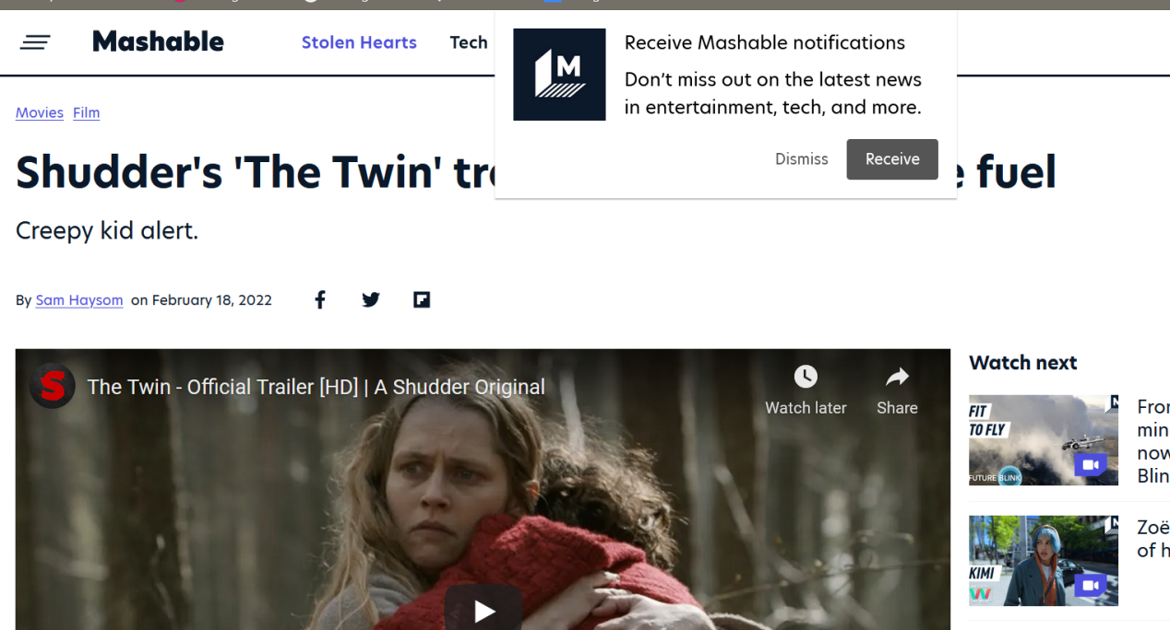

[The above photo shows the Mashable website, it has a notification and loads of links surrounding a video player]

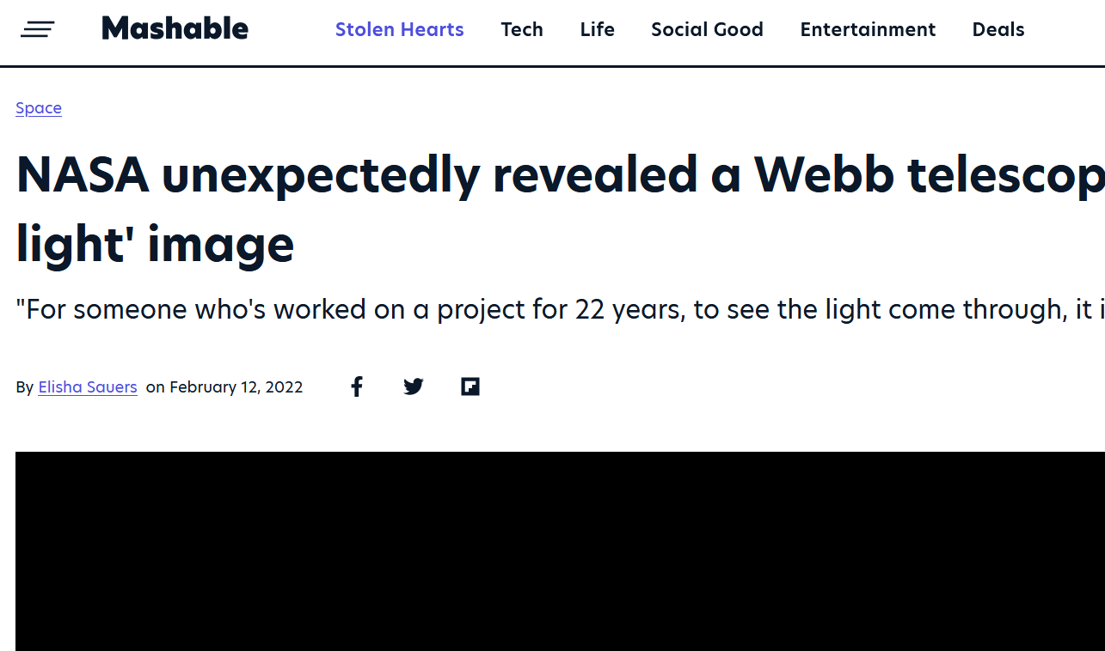

[The above photo shows the Mashable website and the video on the site hasn’t loaded]

I think the site would load faster if they didn’t have loads of other videos around the web page and if the video was smaller on the page. I also think the notification to ask if I want notifications from them might have slowed down the site a little as well. If the photo didn’t load then the site has ALT code inside to say what the photo is.

The second photo shows the video not loading because it was auto-playing it and I think it would have been better if the user just clicked play when the page was fully loaded. The video is using a YouTube HTML because no newly published sites use Adobe Flash Player any more.

**Argos**

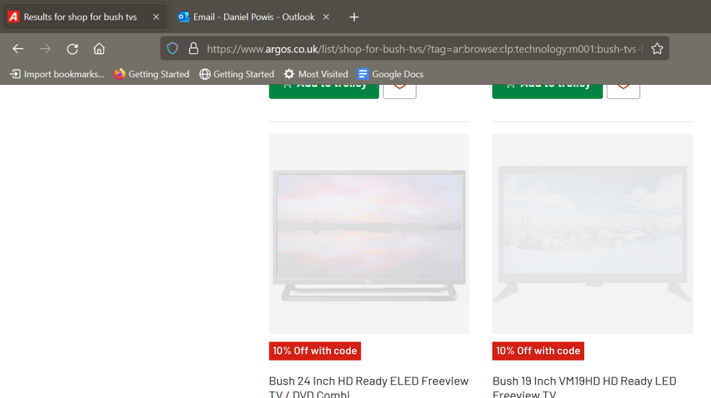

[The above image shows the Argos website and the photos for the TVs haven’t fully loaded in yet]

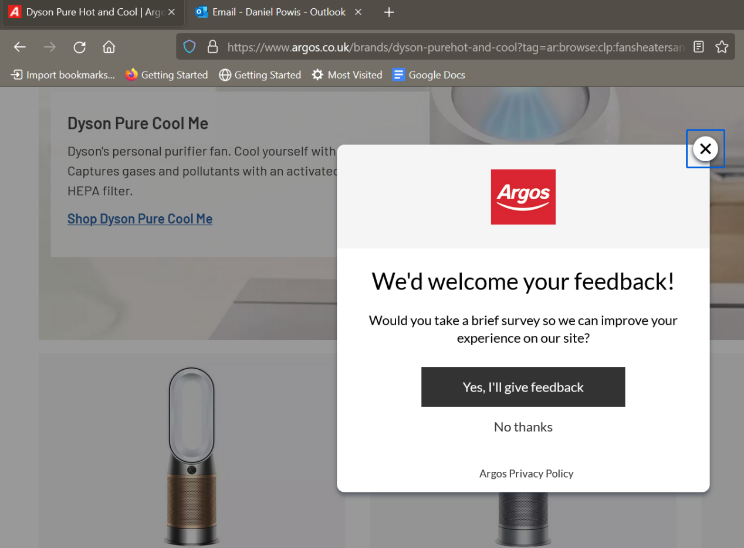

[The above image shows the Argos website and the page has a pop-up asking for feedback]

I think the website would load faster if they didn’t load in their items in automatically or load lower resolution photo on their browsing page and a higher resolution photo when the user clicks the photo. The feedback form also slowed down the page loading and also the user from browsing the site and I think they could just add a bigger link somewhere on the page already rather than it being a pop-up. This site has incorporated ALT in their photos and the pop-up also has accessibility attached.